You will be asked to write one of the following programs in the exam.

However, we will make slight modification to the rules of the game. Make sure you understand your code, and know exactly how to make any modifications during the exam.

Good Luck,

You may have your code on a flash, and you have 5 minutes to load your code and slides to the computer in the lab. You may not use the internet, or phone for any reason.

1. **First Problem**: Your system has a server and 4 clients. The server will create partners with two clients. Each client requests a number from the server. The server provides a number randomly between 1 and 10 for each client. If two clients receive the same number from the server, then they are considered partners. The server will request the clients to establish communication between the partners. The partners will exchange the message “happy to meet you”. For example, after the first request, the clients may have the following numbers
   1. C1 = 3
   2. C2 = 4
   3. C3 = 10
   4. C4 = 1

In this case, no partners are established; go to next trial (جرب مرة اخرى)

In the second round, the clients may get the following numbers

1. C1 = 2
2. C2 = 5
3. C3 = 2
4. C4 = 7

In this trial the clients which have the same numbers are

C1and C3 = 2; so Client1 and 2 become partners

The server sends a message to clients 1 and 3 and ask them to communicate with each other. Clients 1 and 3 establish a connection, and exchange the message “happy to meet you”.

The server continue to generate random numbers for clients 2 and 4.

The server stops trying after a total of 10 trials.

After 10 trials, the server declares the partners in the game, or no partners at all.

For example: if clients 1 and 3 were partners, and 2 and 4 were not partners, the server will declare

Clients1 and 3 are happy partners

Clients 2 and 4 good luck

Note the following cases:

If all clients receive the same random number at any trial, then the server declares clients 1 and 2 as partners, and clients 3 and 4 as partners.

If three clients receive the same random number, then the server declares the first two of the clients as partners, and continue with the game with the other partners.

**Second Problem:**

Consider the graph below

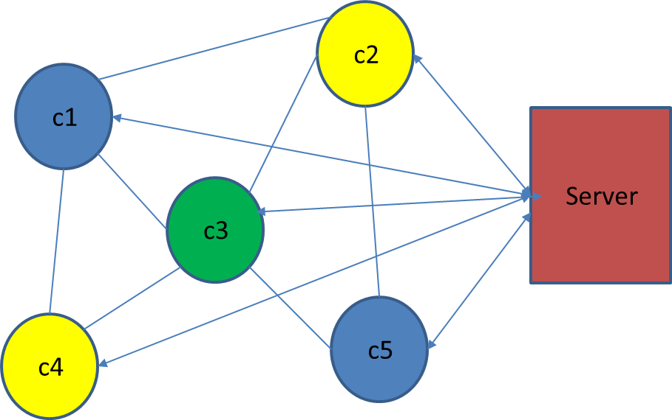

Clients C1, C2, C3, C4, C5 are connected together as shown.

Each client must be colored with a color different from the colors of its neighbors.

For example C1 is blue, and therefore C2, C3, and C4 can not be Blue. C5 can be blue.

And so on.

Initially non of the clients have any color as shown below:

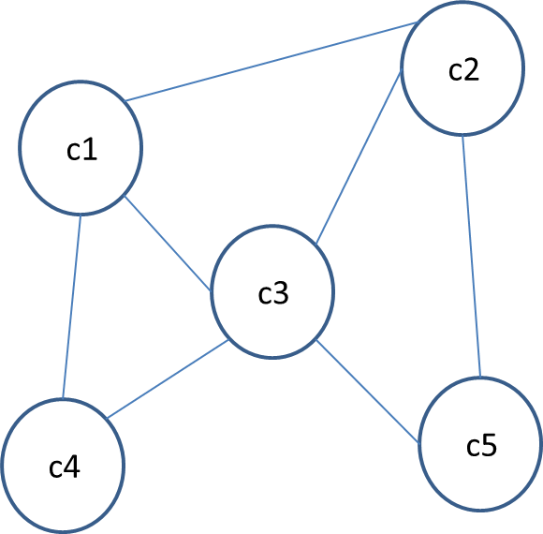

In order to color the graph, the following procedure must be followed

Ci sends a request to the server, andrequest a color. For example C1 requests color blue.

The server checks if any of the neighbors of C1 has the blue color. If no neighbor has requested blue, then the server assigns color Blue to C1. If one of the neighbors of C1 has been colored with Blue, the server asks C1 to select another color.

Each client has three colors to choose from (blue, green, yellow).

Clients do not know the colors assigned to its neighbors. This information is available at the server.

Your program must complete the coloring of the graph, such that no two neighbors have the same color.

Your program must print the final results showing the color of each neighbor. You must make sure that the coloring requirement is achieved.

Your program must print for each client the number of trials made by the client to select the right color.

Note that your program must be able to change the color of a client if a conflict arises during the coloring process.

Your program must print the total turn around time measured from the first trial by the first client until all clients have been fully colored.

Note that your program must be executed sequentially. No thread computation is allowed.